Zachary Cooper  Environmental Designer  ㅡ  Zachary Cooper  602-329-1550  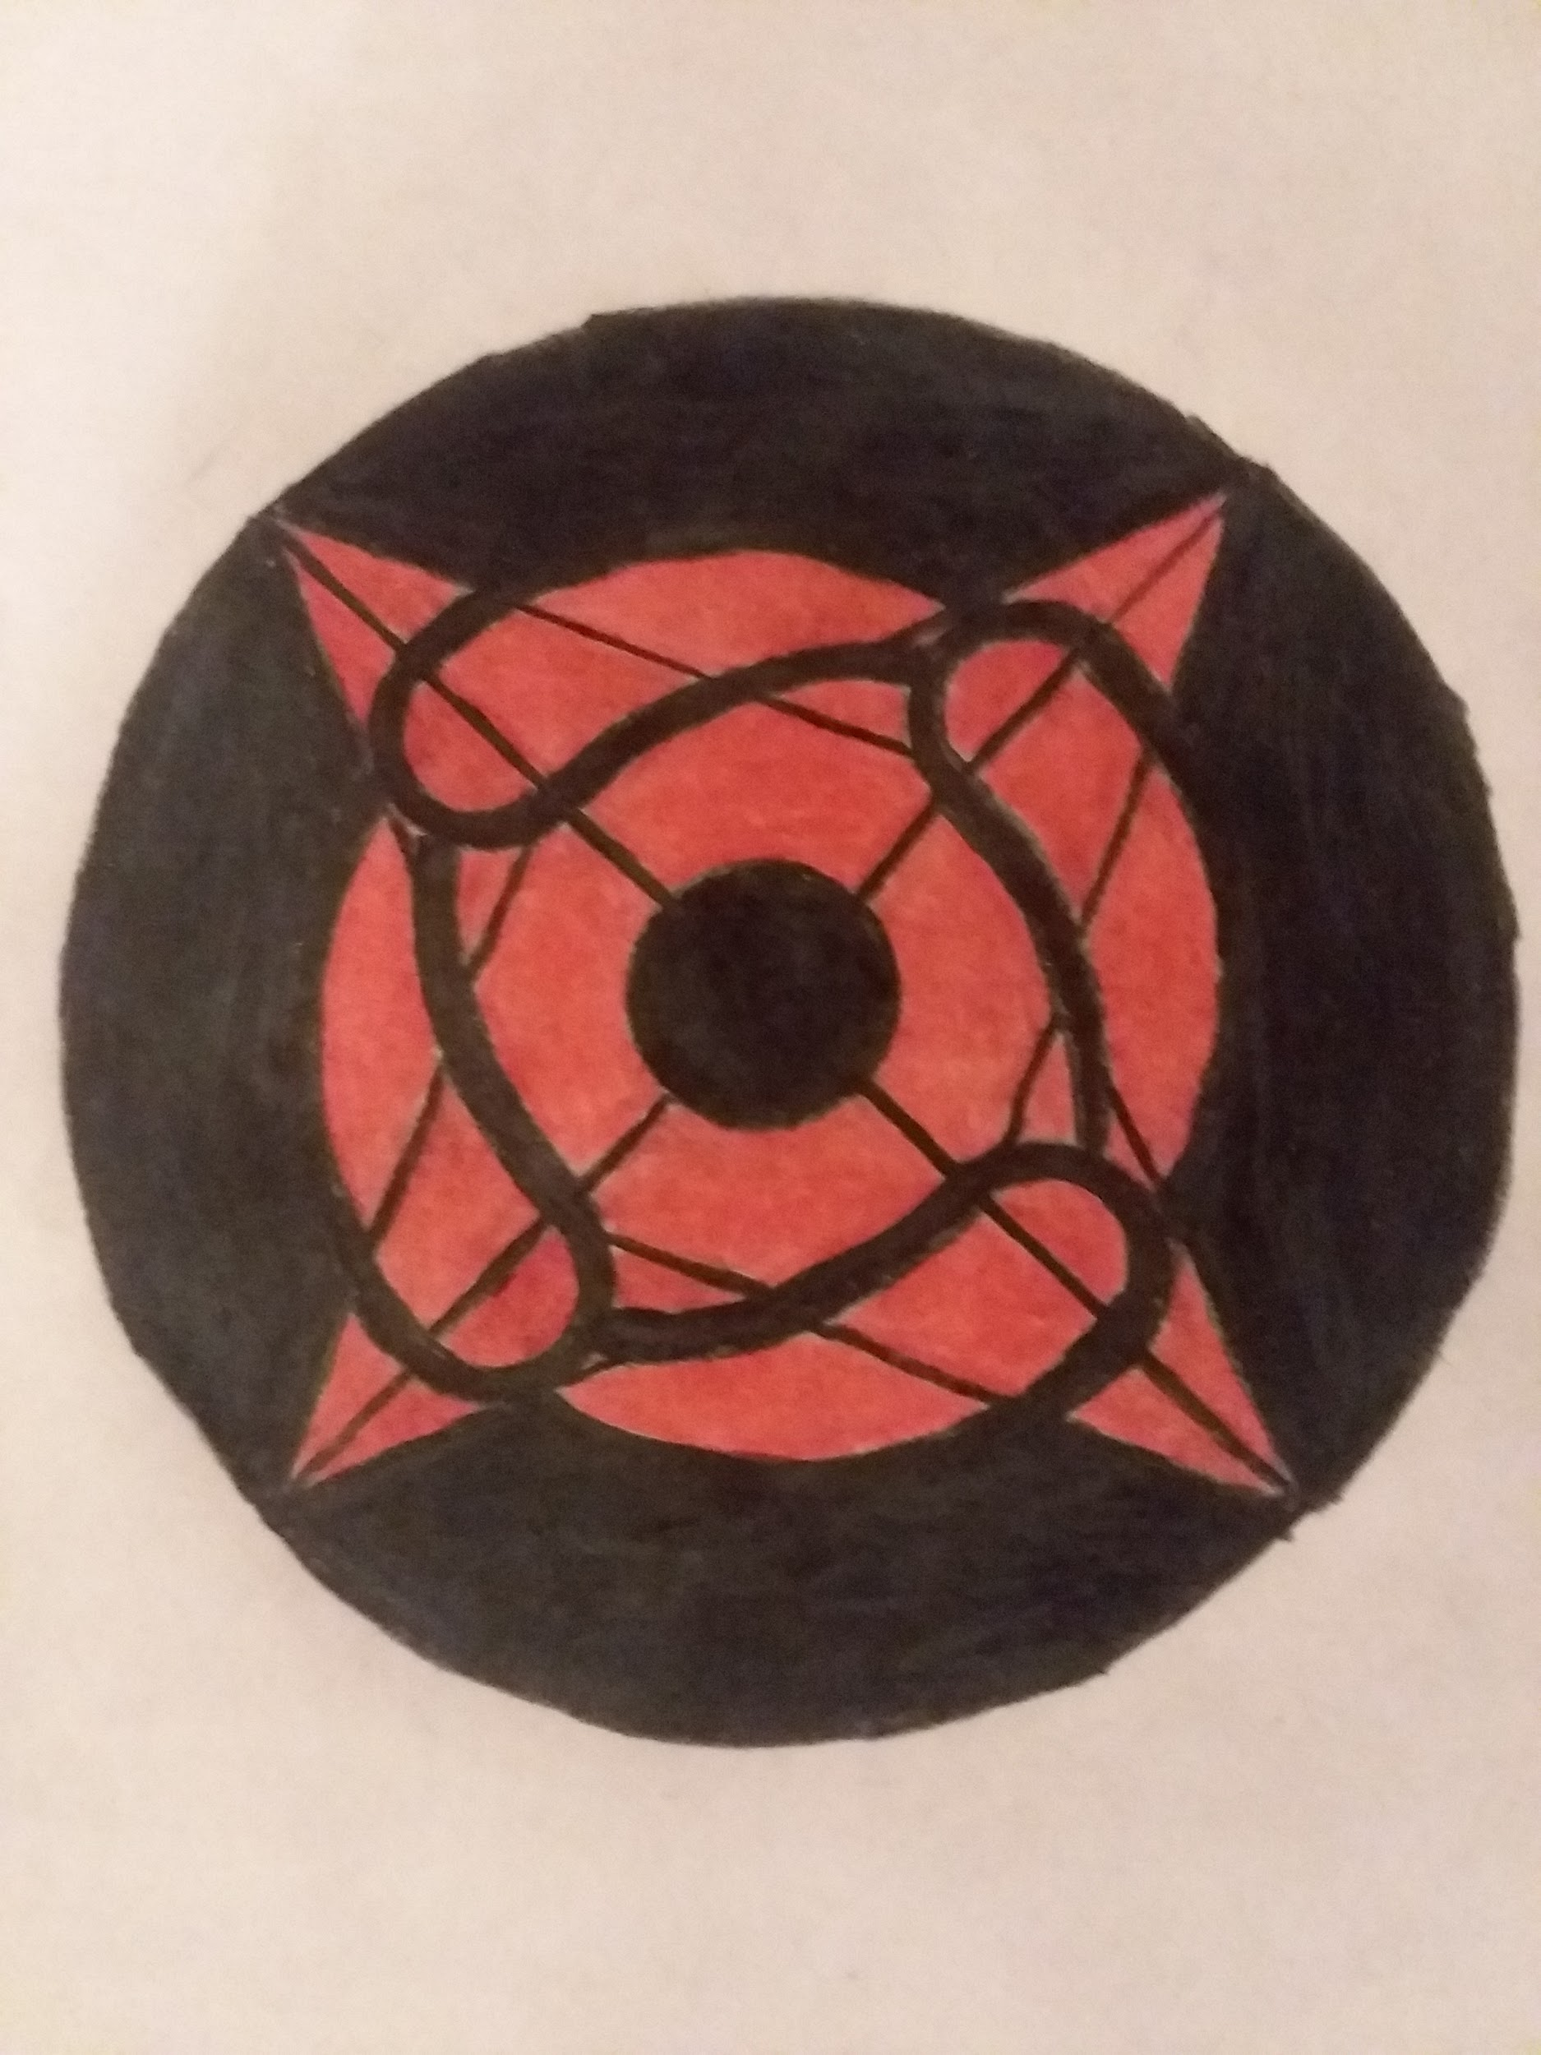  zaccooper2434@gmail.com | For Immediate Release  DESIGN EXPOSITION FOR EASIER LIVING EVERYDAY  Phoenix, AZ ( January 8, 2019) -- With there being so many products we use everyday in our home, there are those that can be used better or improved. By improving the way you use your household items than the easier life will be for you.  New products and new ways of using existing products will be on display at the event. The new products that will be on display will change how you use a current product or fix a issue that can come up while the item is in use. Products with new use will also be on display to agin show views how they can use the item in a more convenient way.  Event Details:  When: Saturday and Sunday, January 12 and 13  Time: 9:00 am to 3:00 pm  Where: Phoenix Convention Center  Cost: $5 entrance fee (plus cost of new product if bought)
As a designer I like to look for ways to improve the way things works. Although the product are designed to be as useful as possible there are situations that other designers did not think of at the time. I like to find those situations and then work on finding a solution to solve that issue.

